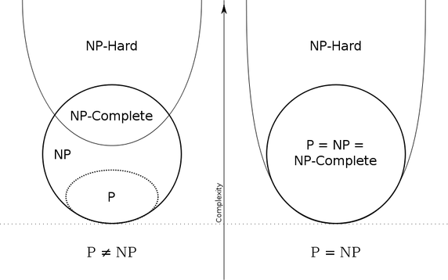

* P - problems that can be solved fast.
* NP - problems whose solutions can be verified fast.
* P = NP - can we have fast algorithms to all the problems whose answers we can verify easily?
* NP-hard - solve one of these fast, and you can solve all the NP problems fast.
* NP-complete - NP-hard and solutions can be verified easily.

**Is P = NP ?**

**Given a problem whose solutions I can check quickly (NP), can I also find an algorithm that can solve this problem quickly (P)?**

Assume that we are given some integers, such as {−7, −3, −2, 5, 8}, and we wish to know whether some of these integers sum up to zero. In this example, the answer is "yes", since the subset of integers {−3, −2, 5} corresponds to the sum (−3) + (−2) + 5 = 0.The task of deciding whether such a subset with sum zero exists is called the **subset sum problem**.

Now, given a candidate solution is pretty straightforward here : just add them! But, actually coming up with the right solution involves a lot of effort - we have to look for a lot of possibilities (exponential, actually). O(2^n*n): 2^n subsets + n to sum up

The answer? We don't know if P=NP

Why do the hardest problems need a separate name for themselves? Because All the "hardest" problems are similar in the fact that if there exists a solution for one, there exists a solution for all. If someone says a problem is NP-Complete, we immediately know that it is a problem whose solution is not known, but if it were, then it will mean there exists a solution for all the other NP-Complete problems, which, as it happens, are important problems across all disciplines of science.

The NP=P? conjecture asks: Is it always true that if we can validate an answer with polynomial operation count we must be able to solve it in polynomial operation count?

**TSP(D):** This is the decision version of TSP. Given n cities 1, ..., n, a nonnegative integer distance dij

between any two cities i and j, and an integer bound B, can we find a tour (visiting each city exactly

once and returning to the starting city) of length at most B?

**TSP(D) is NP-complete**